**PART IB EXPERIMENTAL ENGINEERING**

**SUBJECT: INTEGRATED COURSEWORK EXPT A1**

**LOCATION: DPO (SHORT)**

**DYNAMIC VIBRATION ABSORBER**

**PLEASE BRING YOUR MECHANICS DATA BOOK AND YOUR RESULTS FROM PART IA EXPERIMENT 7 TO THIS LABORATORY**

This experiment is part of the IB Earthquake Vibration of Structures Integrated Coursework. You will simulate the effect of adding a tuned damper to the structure to reduce vibration.

The analysis program is written in Python, and has a graphical user interface (GUI) written using the Tkinter library. To run the program, log on to one of the machines in the DPO then navigate through the menus (top left) to select the item:

*Applications* > *CUED 2nd Year* > *Start1BVibrationAbsorber*

This command should launch a window titled A1 containing the GUI.

All the A1 practical content is accessed via this GUI. However, if you are interested, you can download the Python source code from GitHub, run it on your own computer and even extend it. Instructions are provided in Appendix 2.

# 1 Aims

The aims of this experiment are:  
1. to consolidate and extend some of the vibration theory learned in Part IA;  
2. to investigate some aspects of the design of tuned dynamic vibration absorbers;  
3. to investigate the effects of viscous damping in a typical two-degree-of-freedom system.

# 2 Structural Dynamics Background

A natural frequency of a system is a frequency at which it can vibrate freely in simple harmonic motion, once set in motion. An *n* degree-of-freedom system will possess *n* natural frequencies, and *n* corresponding modes of vibration, which can be determined by solving the equations of motion for the system in free vibration. It is often the case that only the first few modes will be significant.

If a lightly-damped system is excited at or near one of its natural frequencies, large amplitude oscillations will occur. This phenomenon is known as resonance. Such large displacements are likely to cause severe user discomfort in the case of a bridge or building, and may generate stresses large enough to cause ultimate failure. Over a long period, damage due to fatigue may occur. Thus it is important in design to know the natural frequencies of a structure and also the frequencies at which excitation is likely to occur and to keep them apart. In general, the excitation frequencies cannot be controlled, but the natural frequencies of a structure (which depend on its mass and stiffness) can be altered to avoid resonance. Another method of controlling vibrations is to attach a *dynamic vibration absorber* to the system (also known as a *tuned-mass damper)* which will extract energy at a particular frequency (Figure 1).

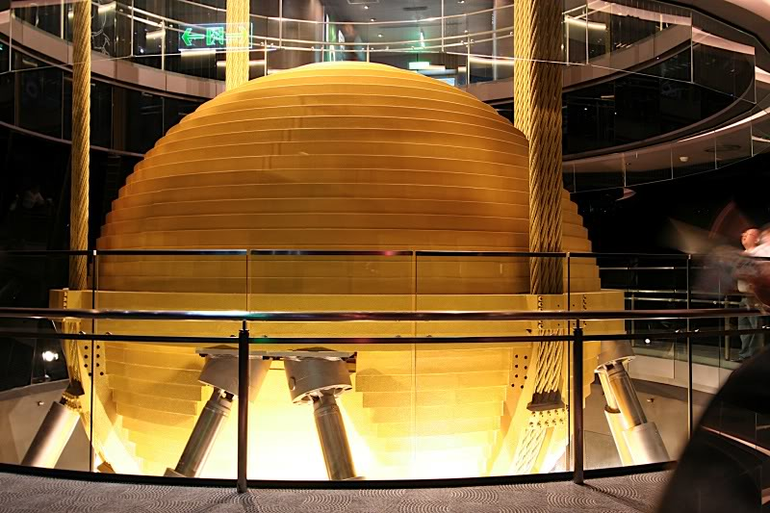

Figure 1: Tuned Vibration Absorber – Taipei 101, Taiwan. This absorber weighs 728 tons, and is suspended on four cables. Its primary purpose is to reduce wind-induced motion.

Structures are often idealised as simple systems for the purpose of analysis. The simplest of these is the single-degree-of-freedom (1DOF) mass-spring system shown in Fig 2. This may be used to model a particular vibration mode of the structure.

*k*

*m*

*f*

*y*

*Figure 2: 1DOF system*

●

In a static analysis, the displacement is given by Hooke’s Law:

$$y=\frac{f}{k}$$

i.e. the static spring force is the only force resisting the loading. However, in a dynamic analysis the loading and displacements vary with time and thus there are also structural velocities and accelerations to take account of. The problem can be expressed in an equation of motion relating inertial, damping, stiffness and loading forces (see Mechanics Data Book page 6):

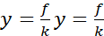

In the absence of damping, the equation of motion in free vibration is 

which can be solved to give the *undamped natural frequency*, 

The *natural period* of the system is then  .

In this situation, an initial perturbation will cause the system to oscillate with constant amplitude forever. Damping provides an energy-loss mechanism which causes the oscillations to die away over time. The *damping rate*  is expressed in Ns/m. The magnitude of the damping rate determines how fast the system will return to its equilibrium position following any perturbation (and for periodic forcing, higher damping rates reduce the oscillation amplitude at resonance). The *critical damping rate*  is the smallest value of  for which oscillations do not occur when the system is displaced and released, and is given by

 (1)

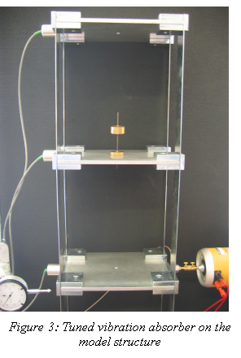The damping of a system can be expressed as a fraction of this critical value  (2)

and the equation of motion can then be rewritten as  (3)

The presence of damping alters the *resonance frequency* of the system; the maximum response of a damped system occurs when

 (4)

A *frequency response graph* for a structure is a curve showing the amplitude of response over a range of forcing frequencies, with a peak occurring at the resonance frequency (see Data Book page 9). The *half-power bandwidth* is the width of the peak at a level  times the maximum amplitude, and is a characteristic which can be used to estimate the amount of damping in the system. The approximate formula for this (accurate when ζ << 1) is

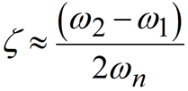 (5)

and  is called “the half-power bandwidth”.

In the case of *n* degree of freedom systems, such simple expressions may only describe the response approximately in the region of a particular vibration mode.

# 3 Introduction to the experiment

Last year, you looked at the response of a model building to a sinusoidal input force. In a full-size building, vibration causes problems of discomfort, damage and possible collapse, so it is important to look at ways to reduce it. In this experiment, you will use a computer model of this building to investigate the effect of a *tuned vibration absorber* (Fig. 3). Such an item can be used on a full-size building to modify the behaviour of the structure – typically, it is used to reduce the response of the structure at resonance.

|  |  |
| --- | --- |
| The A1 GUI is used in this experiment to analyse systems of one or two degrees of freedom. The system parameters are entered in the boxes on the left side of the window. Once values are entered, click Plot, to obtain two graphs   * The “Frequency domain response” showing the steady-state sinusoidal response that the system will settle into if subjected to a sinusoidal force. * The ‘Time domain response’ showing the transient response under the application of a step force. The response dies away and settles into its new steady state. | m2  k2  2  f2  y2  m1  k1    f1  y1 |

A one degree of freedom example is shown below, for sensible parameter values. Make sure that you can reproduce it.

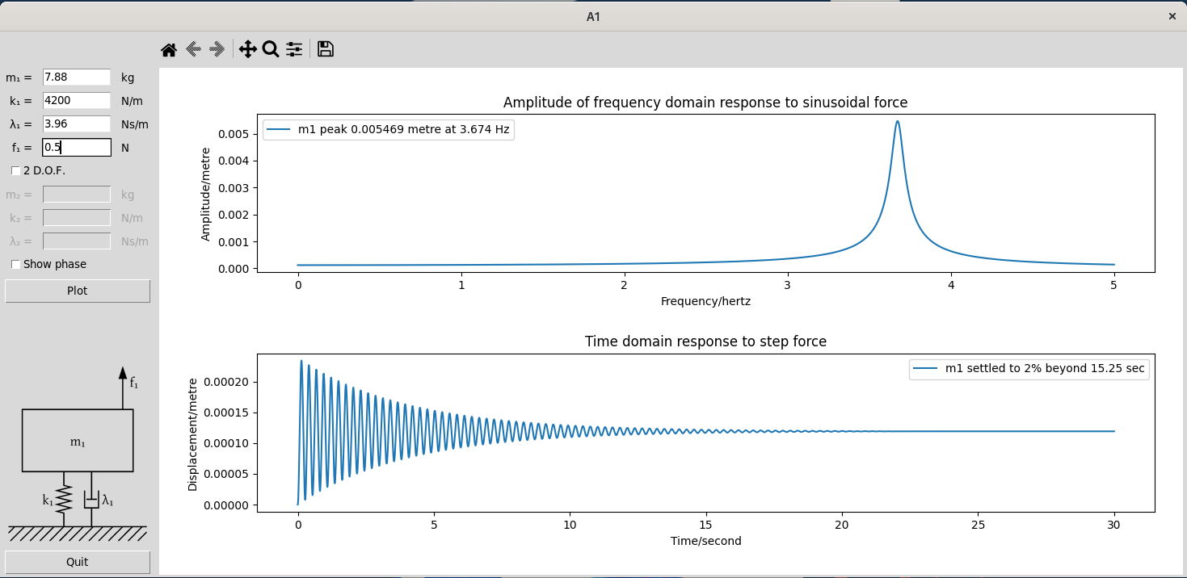

*Figure 4: Screenshot of the Figure window for* m1=7.88, k1=4200, λ1=3.96, f1=0.5

Note that SI units are assumed throughout:   
 mass kg stiffness N/m damping Ns/m  
 force N displacement m  
 time s frequency rad/s or Hz

# 4 Single Degree-of-freedom analysis

Although the model building has 3 degrees of freedom, we look at each vibration mode separately – it is a linear system, so the individual modes can be added together to find the complete response.

First, we will set up the program to model the fundamental (lowest frequency) mode of the structure on its own, (i.e. without the addition of an absorber). This may be modelled as a single mass-spring-dashpot combination, as shown in Fig 2. Figure 5 shows some experimental measurements from one of the structures in the South Wing Mechanics Laboratory. Draw a ‘best fit’ line though the points, and estimate the *resonance frequency*. Then, using a mass of 3.94 kg as an equivalent mass (see the Appendix to learn why this is an appropriate value to use), calculate the *equivalent stiffness* such that the *undamped natural frequency* of the computer model will have this value (This is OK for light damping *i.e.* ξ <<1, for which the resonance frequency is the same as the undamped natural frequency: see equation 4). You should be able to read frequencies from the graph accurate to around 0.01 Hz.

= .................... (in Hz) = ................... radians / second (nb:  = 2 f )

*m* = 3.94 kg so *k* = ........................ N/m

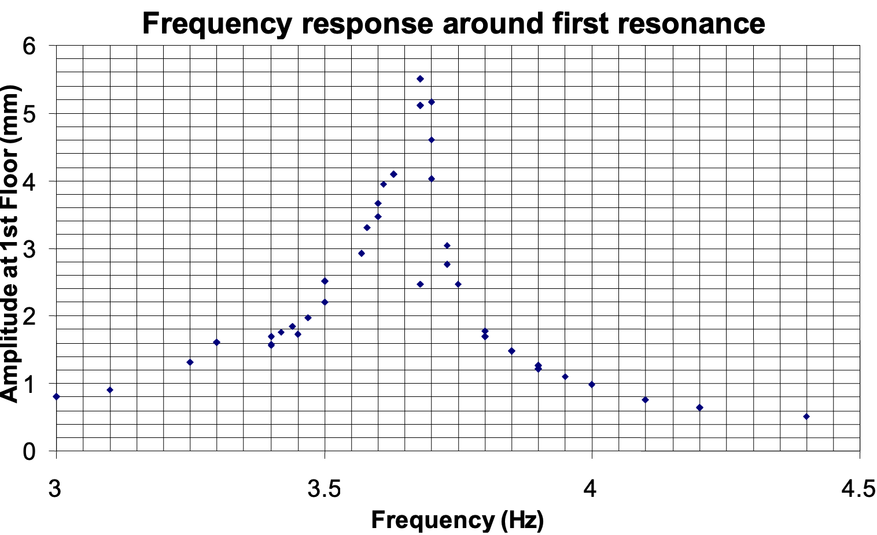

*Figure 5: Experimental results from the model structure with no absorber*

Next, measure the *half-power bandwidth* from Fig. 5, and use equations 1, 5 and 2 (on page 3) to find a suitable value for .

= ................ Ns/m

 = .................. [ Was it valid to assume that, above? ]

 = ................ Ns/m .

## 4.1 Harmonic response: frequency analysis

A model earthquake can be simulated by applying a sinusoidal force to the structure at ground floor level, as in the IA experiment. (This is perhaps not a realistic model of an earthquake, but it provides a useful analysis of the building's response, which can later be extended.) We can now use the computer program to investigate the response of the building in its first mode.

In this section you will need to provide, to the program, values for m1, k1, and λ1.You will also want to adjust f1 so that the peak in the frequency domain response has a height of around 6mm (0.006m). This will make it easy to plot your results on the graph on page 12.

Note the program’s values for (a) the frequency of the peak response and (b) the peak displacement amplitude. Calculate the ratio of peak amplitude to amplitude at zero frequency (get the zero-frequency amplitude either by zooming in on the frequency plot or by zooming in on the steady-state in the time-domain plot). Compare these with the results from Fig. 5 and/or your measured results from last year. Now zoom in and find the half-power bandwidth of the harmonic response and compare this with the value you measured from Fig. 5. Enter your results in the table below.

|  |  |  |  |
| --- | --- | --- | --- |
|  | Frequency of peak  (Hz) | Ratio of amplitude at peak to amplitude at zero frequency | Half-power bandwidth  (Hz) |
| Measured results  (from Fig.5) |  | 41.1 |  |
| Results using computer program |  |  |  |

How well do the results agree? Why might the agreement not be exact?

......................................................................................................................................................

.......................................................................................................................................................

.......................................................................................................................................................

## 4.2 Transient response: time analysis

We would also like to look at the response of the structure to a step input force, which has been included in the programme. This produces a transient response in the structure (as opposed to the steady-state response to a continuous sine wave) and is shown by the bottom graph of the programme output. Possibly this is a more realistic model of an earthquake? Carry out an analysis with a step input force of the same magnitude as you used in the previous section. The bottom graph produced by the program shows the time domain response to a step function of magnitude f1.

Describe the shape of the output response:

.............................................................................................................................................

.............................................................................................................................................

.............................................................................................................................................

# 5 Two Degree-of-Freedom Analysis

  
Figure 7: Tuned absorber to be used  
 on the model structure

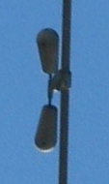  
Figure 8: A Stockbridge damper, used to reduce vibration of overhead power lines





*f*

*y*

*Figure 6: 2DOF system*









Building

Absorber

## 5.1 Optimising the absorber damping

Now consider the addition of a tuned absorber to the model building. This is shown in idealised form in Fig. 6 (a photograph of the absorber used on the model structure is shown in Fig. 7). The moving mass () of the absorber is approximately 0.15 kg.

In this section, in addition to the m1, k1, λ1, f1 parameters you used in §4.1, you will also need to check the 2 D.O.F box in the GUI, so you can also provide values for m2, k2, λ2.

First, calculate the appropriate spring constant  such that the absorber is ‘tuned’ (recall from Part IA, that this requires the undamped natural frequency of the absorber in isolation to be the same as the frequency of the troublesome resonance it is being used to eliminate.)

 = ............................

Now investigate the effect of changing the damping rate  of the absorber over a range of frequencies. For each damping rate considered, look at the **frequency analysis** which allows you to identify the peak harmonic response of both the building and the absorber to harmonic forcing, and the **time analysis** which allows you to identify how long the transient response of the building and the absorber takes to die away.

For the case of = 100 Ns/m (a large value), the dashpot looks like a rigid link, with the building and absorber locked together. Use this “lumped mass” assumption to estimate the frequency of the peak response using the Data Book formula  and compare this with the computer solution.

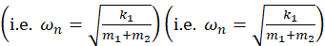

|  |  |  |
| --- | --- | --- |
|  | Data Book formula | computer program |
| Frequency of peak (Hz) |  |  |

Does this result suggest that the computer program is working correctly? ........................

Now investigate the harmonic and transient responses of the building with the absorber fitted, for a range of dashpot rates. You already have the results for λ2 = 100 Ns/m so try the other extreme value of λ2 = 0.01 Ns/m. Next, try a broad range of values between these two extremes, trying to identify damping values where you get a reduction in the response of the structure. (Note that the damping axis is logarithmic, so 0.1, 1.0 and 10.0 Ns/m would cover the range evenly.) In the neighbourhood of the lowest values, try a narrower range of damping values to identify the optimum value – that is, the one which gives:

1. the minimum value of peak harmonic response of the building and
2. a fast decay of the step response of the building.

Write your results (to 3 significant figures) in the table below, and plot a graph of the peak harmonic response of the building as a function of damping, using the graph paper at the end of this handout. **Plot the results as you go**, so that you can quickly see which values of  to explore in more detail.

The time for the response to decay completely is theoretically infinite – a practical alternative is to calculate the limits of an envelope which covers 2% of the equilibrium response at either side of this value, and identify the time taken for the response to enter this envelope and not leave it again (as may happen when modulation occurs). Any decay time longer than 30 seconds is of no interest, so there is no need to record times once they exceed this.

|  |  |  |  |
| --- | --- | --- | --- |
| Damping  *Ns/m* | Peak harmonic response of building  *mm* | Peak harmonic response of absorber  *mm* | Time for response to decay to within 2% of the equilibrium position *s* |
|  |  |  |  |
|  |  |  |  |
|  |  |  |  |
|  |  |  |  |
|  |  |  |  |
|  |  |  |  |
|  |  |  |  |
|  |  |  |  |
|  |  |  |  |
|  |  |  |  |

1. What damping rate do you recommend for the dynamic absorber, and why?

.............................................................................................................................................

.............................................................................................................................................

2. Give a numerical measure of the effectiveness of a vibration absorber which uses the damping rate you have recommended. (In other words, find a formula which gives a measure of an absorber’s effectiveness, and use it to calculate your absorber’s score.)

.............................................................................................................................................

.............................................................................................................................................

.............................................................................................................................................

3. Explain the reason for the ‘modulation’ (i.e., the periodic variation in amplitude) of the time response:

.............................................................................................................................................

.............................................................................................................................................

.............................................................................................................................................

.............................................................................................................................................

4. Sketch and explain the shape of the frequency response graph:

|  |  |  |
| --- | --- | --- |
| Low damping | Optimal damping | High damping |
|  |  |  |

Low damping.......................................................................................................................

.............................................................................................................................................

.............................................................................................................................................

Optimal damping.................................................................................................................

.............................................................................................................................................

.............................................................................................................................................

High damping .....................................................................................................................

.............................................................................................................................................

.............................................................................................................................................

5. Sketch and explain the shape of the time response graph:

|  |  |  |
| --- | --- | --- |
| Low damping | Optimal damping | High damping |
|  |  |  |

Low damping.......................................................................................................................

.............................................................................................................................................

.............................................................................................................................................

Optimal damping.................................................................................................................

.............................................................................................................................................

.............................................................................................................................................

High damping .....................................................................................................................

.............................................................................................................................................

.............................................................................................................................................

6. Can you think of a way to improve the effectiveness of the dynamic vibration absorber? (Hint: looking at the Appendix opposite might help!)

.............................................................................................................................................

.............................................................................................................................................

.............................................................................................................................................

.............................................................................................................................................

.............................................................................................................................................

JSB 2023, HEMH October 2020, JPT 2019, ALJ 2017, AR / HEMH, 2007

# Appendix 1: Choice of equivalent mass

When setting up a simple mass-spring-damper model to simulate the behaviour of a more complex (but lightly damped) system around one of its resonance frequencies, the first goal is to ensure that the model has the same resonance frequency as the real system. This requires that:



where *m'* and *k'* are the equivalent mass and spring values in the model, and *n* is the required resonance frequency. This ratio can be achieved by choosing either a small mass and a weak spring, or a larger mass and a stiffer spring. If the model is going to be used to predict the effectiveness of a vibration absorber (as in this experiment), then it is necessary to choose values for *k'* and *m'* such that the model has the same ‘feel’ as the real system, at the place where the absorber is to be attached.

Suppose we are planning to attach the vibration absorber to the second floor of the three-floor building shown in Fig. 3. We now set up our equivalent model as shown in Fig. A.1.

The real system consists of thee equal masses connected together by springs of equal stiffness. The theory taught in the IA vibrations course can be used to calculate the modal shape of the system at its first natural frequency. The results of this calculation (easy to obtain in Matlab) are shown below.

*a*

*a*

0.555 *a*

*m*

*m*

*m*

*k*

*k*

*k*

*m'*

*k'*

≡

floor 1

floor 2

floor 3

1.247 *a*

*Figure A.1: Modelling the system*

It can be shown[1] that the system on the left and the model on the right are matched if the same amount of energy is required in each case to cause a given amplitude (in this case, *a*) at the point of interest. When an undamped system is vibrating freely, the *elastic energy* stored at the instants when it is stationary (i.e. at the two extremes of its motion) will be the same as its *kinetic energy* when the deflections are all zero (i.e. halfway between the two extremes). Using the amplitudes from the Figure, the kinetic energy at zero deflection can be calculated as:



where ** is the frequency of vibration. Since the measured value of *m* is 1.375 kg, the appropriate value to choose for *m'* in the model is 2.863 × 1.375 ≈ 3.94 kg[2]. .

Similarly, if the vibration absorber was to be fixed to the first floor, the equivalent mass calculated above should be increased by a factor of 1/0.5552 (can you see why?), to give 12.78 kg.

# Appendix 2: Python Code

You can download the Python source code for this practical from GitHub, so you can run it on your own computer and even extend it:

<https://github.com/CambridgeEngineering/PartIB-Paper1-Vibration-Absorber-Lab>

The analysis and plotting is done by the simple command line program, a1.py. The repository also contains a1_GUI.py that creates a GUI for a1.py. However, if you are interested in editing or extending the code, it is more straightforward to run a1.py directly.

Before running a1.py at home on a PC, you will need to have first downloaded and installed python3, and also the modulus “numpy”, “scipy” and “matplotlib” (eg “pip install numpy” or “pip3 install numpy” depending on your platform).

Next,open a terminal/command_prompt, and navigate to where the file a1.py resides, and run the script. The exact terminal command required depends on your system, but is likely a1.py, python a1.py, or python3 a1.py.

When you run a1.py in a terminal, it will complete the analysis with a set of default parameters, and the resulting step-response and frequency-response graphs will be plotted. To see what the default values are run a1.py --help which shows default values in [ ]:

> a1.py --help  
usage: Plot response curves [-h] [--m1 M1] [--l1 L1] [--k1 K1] [--f1 F1] [--m2 M2] [--l2 L2] [--k2 K2] [--f2 F2] [--hz HZ HZ] [--sec SEC]

|  |  |
| --- | --- |
| optional arguments:  -h, --help show this help message and exit  --m1 M1 Mass 1 [7.88]  --l1 L1 Damping 1 [3.96]  --k1 K1 Spring 1 [4200]  --f1 F1 Force 1 [0.5]  --m2 M2 Mass 2 [None]  --l2 L2 Damping 2 [1]  --k2 K2 Spring 2 [106.8]  --f2 F2 Force 2 [0]  --hz HZ HZ Frequency range [0 5]  --sec SEC Time limit [30]  To modify any of the parameters, *eg* to put m1 =5.5kg and k1 =4000N/m then use the following syntax:  a1.py –-m1 5.5 --k1 4000 | m2  k2  2  f2  y2  m1  k1    f1  y1 |

Note that a1.py already includes some additional functionality compared to the GUI: a force on the upper mass. You can now open a1.py in any text editor, to see how it works, and make any extensions. Moreover, many likely extended exercises can be accomplished without editing a1.py itself, but by importing it and calling the functions it contains with arguments of your own devising.

N.B. a1_GUI.py requires (at least) Python 3.9, whereas a1.py is probably more relaxed.



1. This material is fully covered in Part IIA, in Module 3C6
2. There is no need for more than three significant figures here – the model is only approximate!